Task-Based Activity: Use a grocery store flyer to plan purchases for a party
Laubach Connection: Laubach Way to Reading (LWR) Book 3, Lesson 8
OALCF Link
Relevant Goal Paths
Employment, Independence
Rationale: Learners on the Employment and Independence Paths may need to read flyers to make purchases for a variety of different reasons.

Task-Based Activity Description: The learner will read a document (grocery store advertisement) and make simple cost calculations.
Competency, Task Group and Level Indicators
(See Assessment page for performance descriptors)
A: Find and Use Information
A2: Interpret documents
- A2.1 Interpret very simple documents to locate specific details

C: Understand and Use Numbers
C1: Manage money
- C1.1 Compare costs and make simple calculations

Materials Required
- Pen or pencil and eraser
- Question sheets

Overview
Activity Introduction
This task uses a grocery store flyer.

In lesson eight, the class is having a party. Discuss with the learner whether they have ever planned a party before and if they use grocery store flyers to help them shop. Discuss with the learner the importance of using flyers to see what is on sale and possibly save money.

New words
Determine any new words that you think are being introduced in the activity and review those words with the learner.

Instructions
- Have the learner fill in their name and the date.
- Have the learner complete the pre self-assessment.
- Have the learner complete the task-based activity.
- After completing the activity have the learner complete the post self-assessment.
- After the learner has completed the task-based activity complete the assessment section and review the results with the learner.

Extension activities
- Use various flyers to compare prices of like items

Task-Based Activity: Use a grocery store flyer to plan purchases for a party

Learner Name: _____________________________ Date: ____________________________

Pre self-assessment

I need to improve my skills at:
- Yes
- No

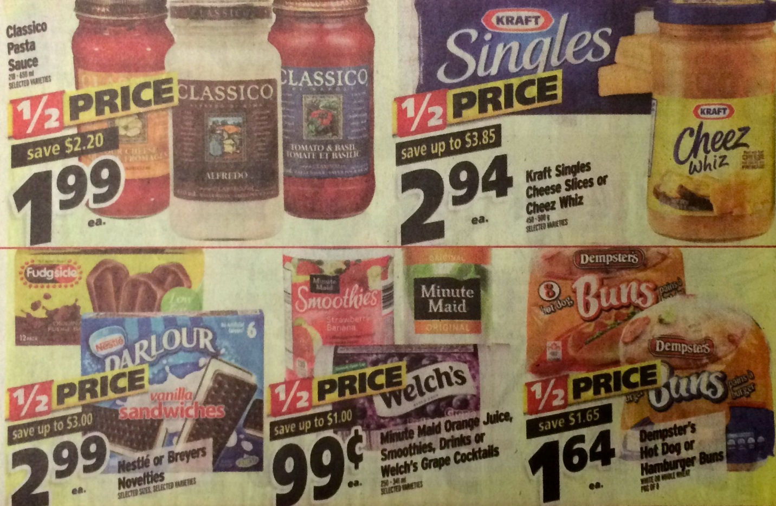

You are planning a party for 12 people. You will be serving cheeseburgers, juice, and frozen treats. Use the flyer provided to help you calculate the costs for some of the items you will need.

- There are 12 frozen treats in a box of fudgsicles and 6 frozen treats in a box of vanilla ice cream sandwiches. If every guest has one frozen treat, what type of treat would be less expensive to serve? ________________________________________________________

- How much does each frozen juice usually cost (when it isn’t on sale)?________________

- If you estimate that you will need one frozen juice for every three guests, how many frozen juice should you purchase? ____________________________________________

- What will the total cost be if you buy one box of frozen treats, four frozen juices, two packs of buns, and one pack of cheese slices? __________________________________

Post self-assessment

I think my skills have improved as a result of completing this activity.
- Yes
- No

Learner comments:
_________________________________________________________________________________________________
_________________________________________________________________________________________________
________________________________________________________________________________________________

Assessment
Task-Based Activity: Use a grocery store flyer to plan purchases for a party
Learner Name: _____________________________ Date: ____________________________

Practitioner Name: _______________________________________

Performance Descriptors | Needs Work | Improving | Excellent
A2.1: Interpret very simple documents to locate specific details
- scans to locate specific details
- interprets brief text and common symbols
- locates specific details in simple documents, such as labels and signs
- identifies how lists are organized (e.g. sequential, chronological, alphabetical)
- requires support to identify sources and to evaluate and integrate information

C1.1: Compare costs and make simple calculations
- adds, subtracts, multiplies and divides whole numbers and decimals
- recognizes values in number and word format
- understands numerical order
- begins to interpret integers, such as in a negative bank balance
- identifies and performs required operation
- follows apparent steps to reach solutions
- interprets and represents costs using monetary symbols and decimals
- rounds to the nearest dollar
- uses strategies to check accuracy (e.g. estimating, using a calculator, repeating a calculation, using the reverse operation)
The learner needs to work on the following:

This task was successfully completed ______ This task needs to be tried again ______

Practitioner Comments:

Learner Comments:

